 Vitense She-Ra League Rules
Format:
During the regular season you will play with 3 other ladies at your bay playing 9 holes. Scoring is Stableford scoring which means you get points on Birdies, Pars, Bogeys, and other scores.
Scoring:
Points that are offered for all scores
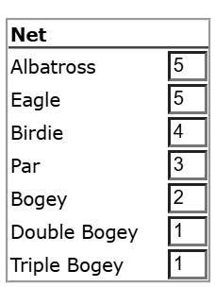
IMAGolfer: Learn it/Use it!!!
Everyone will receive an invitation via email to login into our league software – returning members will use the same login/password as last year. IMAGolfer will show your tee times each week (and course you play), current standings in each division, your personal stats, and allow you to find subs. Please login and use it – and make sure you are at the course before your tee time.
Handicaps:
All handicaps will be carried over from rounds played in previous years. New league members will be given an initial handicap based on either a WSGA or by an average score estimate. Handicaps will be calculated using your best 2 scores out of your last 10 league rounds and we will use 80% of that average. For handicapping purposes and pace of play, the ‘triple rule’ is in effect – you cannot card anything higher than a triple bogey on any hole (but actual scores will be used to determine the match point).
SUBS:
It is your responsibility to find a sub any week you cannot make it. There is a sub list built into IMAGolfer. Any subs that play must have either an established league handicap, or a wsga/usga handicap to get strokes. Subs will play as their normal handicaps.

Bad Weather:
Always assume we are playing. If it’s going to be too cold or too much snow, We will make a decision by 2:30 and send an email out at that time. Please do not call us prior to 2:30pm and ask if we are playing (Glynn rule).
Misc Rules:
- Each week we will play from the “Red” Tees.
- Putting is a little different, you will chip the ball to one of 2 different rings. This will determine a 1,2 or 3 putt. The 1st night of league play I will go over this with everyone. It’s easy once you see how its done and makes each round much faster.
- Pace of Play – We start Playing each round at 6pm on Tuesdays. With 4 players playing it should take about 2 hours.
- Scorecards must be turned in to the designated area “The Front Counter”– I will log in all scores. All I need on the scorecard is a hole by hole score (neatly written) for each player, the software will figure out the match points. It’s up to you to make sure you have a complete and accurate card before it gets turned in.

